
701 Osage Street, Unit 120 Phone 303-892-0400
Denver, CO 80204 Toll Free 800-333-4234
www.bisonip.com Fax 303-825-5988

The Bison ScrewJack (B-Series) Adjustable Pedestal line has a broad footprint that provides stability, is impervious to freeze thaw cycles, and offers a range of heights suited to a wide variety of applications. Precise spacer tabs allow for deck drainage and uniform paver spacing, simple accessories adjust for slope, and the screw-to-adjust height settings assure a perfectly level deck. The Bison ScrewJack Pedestal series reaches heights from 1-1/4” to 36” and has a weight bearing capacity of 1000 lbs (FoS:3). Accessories are available to compensate for additional slope and accommodate heights from 1/8” to 1-1/4”. Use ScrewJack Pedestals with the Bison Brace System for excess height installations (from 24” to 36” in height) or for installations requiring additional stability. Proudly manufactured in the U.S.A.

NOTE: Bison ScrewJack Pedestals are sold exclusively in the U.S.A. through Oldcastle Westile.

ScrewJack B-Series Specification
SECTION 065200 – Plastic Structural Assemblies

- GENERAL

  - SECTION INCLUDES
** NOTE TO SPECIFIER ** Delete items below not required for project.
- Bison ScrewJack Adjustable Pedestals and Accessories.

  - RELATED SECTIONS
** NOTE TO SPECIFIER ** Delete any sections below not relevant to this project; add others as required.
- Section 061500 – Wood Decking
- Section 065300 – Plastic Decking
- Section 067313 – Composite Structural Decking
- Section 075000 – Membrane Roofing
- Section 077246 – Roof Walkways
- Section 077600 – Roof Pavers
- Section 096900 – Access Flooring

  - REFERENCES
** NOTE TO SPECIFIER ** Delete references from the list below that are not actually required by the text of the edited section.
- ASTM D256 – Standard Test Methods for Determining the Izod Pendulum Impact Resistance of Plastics
- ASTM D543 – Standard Practices for Evaluating the Resistance of Plastics to Chemical Reagents (NaOH and HCl)
- ASTM D635 – Standard Test Method for Rate of Burning and/or Extent and Time of Burning Plastics in a Horizontal Position
- ASTM D638 – Standard Test Method for Tensile Properties of Plastics
- ASTM D648 – Standard Test Method for Deflection Temperature of Plastics Under Flexural Load in the Edgewise Position
- ASTM D790 – Standard Test Methods for Flexural Properties of Unreinforced and Reinforced Plastics
- ASTM D792 – Standard Test Methods for Density and Specific Gravity (Relative Density) of Plastics by Displacement
- ASTM D1238 – Standard Test Method for Melt Flow Rates of Thermoplastics by Extrusion Plastometer
- ASTM D1929 – Standard Test Method for Determining Ignition Temperatures of Plastics (both FIT and SIT designations)
- ASTM D2240 – Standard Test Method for Rubber Property-Durometer Hardness
- ASTM D2843 – Standard Test Method for Density of Smoke from the Burning or Decomposition of Plastics
- ASTM D5420 – Impact Resistance (Gardner Impact)
- ASTM G155 – Accelerated Weathering/ Light Exposure using Xenon Arc Light Apparatus for Non-Metallic Materials
- FBC TAS 110-2000 – Testing Requirements for Physical Properties of Roof Membranes, Insulation, Coatings, and Other Roofing Components
- UL 94 – Standard for Tests for Flammability of Plastic Materials for Parts in Devices and Appliances
- UL 790 – Tests for Fire Resistance of Roof Covering Materials (equivalent to ASTM E108)

  - SUBMITTALS
    - Submit under provisions of Section 013300.
    - Product Data: Manufacturer's data sheets on each product to be used, including:
      - Preparation instructions and recommendations.
      - Storage and handling requirements and recommendations.
      - Installation methods.
    - Shop Drawings: Submit shop drawings detailing the installation methods. Coordinate placement with locations noted on the Contract Drawings.
    - Fire Resistance Ratings: As required for exterior pedestal supported deck system by the presiding jurisdiction.
    - Wind Uplift Ratings: As required for exterior air permeable pedestal supported deck systems by the presiding jurisdiction.

  - QUALITY ASSURANCE
    - Manufacturer Qualifications: All primary products specified in this section will be supplied by a single Manufacturer with a minimum of ten (10) years of experience.
    - Installer Qualifications: Bison recommends the Installer have a minimum of two (2) years proven construction experience, be capable of estimating and building from plans and details, determining elevations, and properly handling materials. All work must comply with the Bison installation procedures for pedestals specified herein.
** NOTE TO SPECIFIER ** Retain the following section if the pedestal system is installed over a roofing or waterproofing membrane. Delete if not required.
    - Special Considerations: The Contractor assumes the responsibility for and must take into consideration the structural capability and adequacy of the structure to carry the static and live load weight(s) involved, and that the density of any insulation is satisfactory to resist crushing and damaging the waterproofing membrane.
    - The Bison Pedestal System is not intended to be part of a ballasted roofing system and does not shield the underlying roofing system from wind or other loads. The underlying roofing system must be capable of resisting the full design wind or other loads appropriate for a specific project.
** NOTE TO SPECIFIER ** Include a mock-up if the project size and/or quality warrant such precaution. The following is one example of how a mock-up on a large project might be specified. When deciding on the extent of the mock-up, consider all the major different types of work on the project. Make changes as necessary.
    - Mock-Up: Provide a mock-up for evaluation of surface preparation techniques and application workmanship.
      - Finish areas designated by Architect.
      - Do not proceed with remaining work until workmanship is approved by Architect (if applicable).
      - Refinish mock-up area as required to produce acceptable work.

  - DELIVERY, STORAGE, AND HANDLING
    - In each Order include an additional 2-5% in spare materials to have on hand for damage replacement; depending on the size of the job and as directed by the Architect.
    - Immediately upon receipt inspect all delivered materials to ensure they are undamaged and in good condition. Claims for damages must be made to the Driver/Carrier prior to accepting delivery. Note any visual damage to containers or packaging material on the bill of lading before the Driver leaves. Any damage should be noted on the bill of lading, photographed, and then reported to Bison immediately. Please save all product packaging for a short period of time in case return shipping is required.
    - Deliver and store Bison pedestals and system components with labels intact and legible.
    - Store Bison products in an enclosed or covered area protected from the elements as site conditions allow.
    - Store and dispose of solvent-based materials such as construction adhesive, and materials used with solvent-based materials, in accordance with requirements of local authorities having jurisdiction.

  - PROJECT CONDITIONS
    - Bison Pedestals listed in this section are for use with pedestrian traffic only. Bison Pedestals are not designed to support decks that carry vehicular traffic or equipment, including but not limited to motorized snow removal equipment, window washing, scaffolding structures, ATV’s, forklifts, or any motorized vehicles.
    - There are no installation temperature restriction guidelines other than the practical considerations of working in unsafe or inclement weather.
    - IMPORTANT: It is the responsibility of the Architect or Engineer of Record to make sure the installation of the Bison Pedestal System meets all local and national codes.
    - Perimeter Walls and Containment:
      - All decks must be restrained by perimeter blocking or walls on all sides, including “on-grade” installations. There should be no more than a 3/16” (4.5 mm) gap between deck tiles or pavers, or at any perimeter edge, and the deck should not exhibit any lateral movement.
      - It is recommended that deck tiles or pavers sit above the waterproofing, integral flashing, and/or counter flashing. In situations where the perimeter of the deck comes into contact with the flashing material, a protective wall covering should be specified if deemed necessary.
** NOTE TO SPECIFIER ** Retain the following section if large features such as planters, heavy benches, water features, hot tubs, etc. are being installed on top of the pedestal system.
    - Any deck features that impose a concentrated load must have extra pedestal supports in addition to the primary pedestal system supporting the walk deck.
      - A minimum of one additional pedestal support must be installed for every 500 lbs (227 kg) (or portion thereof) of static loading. These additional support pedestals must be installed directly under the decking and evenly spaced immediately below the feature locations. One additional pedestal must be placed under each corner of any rectangular feature.
      - When installing Bison Cubes, additional support may be needed under the center and corners of the Cubes depending on the size and anticipated weight loads.
      - Features supported by legs or feet are not advised and are considered unacceptable because of the dangers of point loading.
      - Any feature that creates vibration, cell phone towers, heavy planters, and other similar features require their own separate support designed by the Architect or Engineer of Record.
    - All decks shall be designed to not exceed the weight bearing capacity of the pedestal system.
    - The substrate immediately below the pedestals shall provide positive drainage.
** NOTE TO SPECIFIER ** Retain 1.7H-1.7I if the pedestal system is being installed over a roofing or waterproofing membrane. Delete if not required. Retain either 1.7J (insulation density 20-40 psi) or 1.7K (insulation density >40psi).
    - Roof systems must meet local building code and be in accordance with the NRCA recommended good construction practices. Only roofing manufacturer approved systems shall be used.
    - A 12” x 12” (305 x 305 mm) piece of installed membrane may be used as a separate protective slip sheet underneath each pedestal if recommended by the substrate manufacturer.
    - Pedestals must be supported by a surface that provides 40 psi bearing capacity.
      - Suggested methods to accomplish the noninvasive and required support:
        - Incorporate a thin cap bearing protective layer insulation specifications that call for a very thin protective layer to be installed on top of the common 20 psi insulation. Such a cap type insulation product is commonly formed as a thin, dense, low-foamed, polyisocyanurate layer and provides the necessary pedestal support.
        - The Bison Floating Insulation Base (FIB) is an enlarged base that distributes the anticipated loaded weight of a pedestal over a larger area. The FIB is designed to be installed directly over Type 1 roof systems that incorporate 20 – 40 psi common insulation boards.
        - Insulation above the Membrane: Install a 1-1/2” (38 mm) thick (min.) layer of dense, closed-cell 40 psi (min.) extruded-cell polystyrene insulation board above the common roofing system that has buried insulation to provide support for the pedestal system.
    - Bison Pedestals can be installed directly on top of 40 psi, or greater, extruded closed-cell polystyrene insulation with 1-1/2” (38 mm) thickness or greater. Install deck system pedestals directly on the insulation prior to the installation of ballast rock. Seek alternative methods of ballasting until deck installation is completed. The Bison Pedestal System is not intended to be part of a ballasted roofing system and does not shield the underlying roofing system from wind or other loads. The underlying roofing system must be capable of resisting the full design wind or other loads appropriate for a specific project.
** NOTE TO SPECIFIER ** Retain the following section if the pedestal system is installed on grade (soil). Delete if not required.
    - Decks on grade:
      - Any substrate soil receiving pedestals shall be adequately compacted and have positive drainage slope. A “walkway gravel” base should be installed and compacted at pedestal locations.
      - Bison Floating Foundation Bases (FFB) must be used beneath all on-grade Bison Pedestal decks. Level the soil surface and install FFBs directly on grade as a base for each pedestal.
      - Install structural perimeter containment which restrains the entire decking system. There should be no more than a 3/16” (4.5 mm) gap between deck tiles or pavers, or at any perimeter edge, and the deck should not exhibit any lateral movement.

  - WARRANTY
    - At project closeout and upon request, Bison can provide to the Owner, or the Owner’s Representative, an executed copy of the Manufacturer’s standard document outlining the terms, conditions, and limitations of their limited warranty against manufacturing defects for a period of five (5) years. Bison must approve all warranty related repairs, and unauthorized repairs void this limited warranty.
    - The Contractor warrants that his work will remain free from defects in material and workmanship in accordance with the General Conditions for this project or a minimum of five (5) years.
    - It is the responsibility of the Contractor installing the product listed in this section to coordinate warranty requirements with any related sections or adjacent work. Notify the Architect immediately of any potential lapses or limitations in warranty coverage.
    - For use with pedestrian traffic only. Never use Bison pedestals to support or construct decks that have wheeled, motorized, or equipment traffic.
    - Deck must be restrained on all sides to prevent lateral movement. There should be no more than a 3/16” (4.5 mm) gap between deck tiles or pavers, or at any perimeter edge.
    - Bison Pedestals are covered by a limited five (5) year warranty. Bison Pedestals are warrantied to the original owner to be free of defects in material and workmanship for the period of five (5) years from the date of purchase. Defects are defined as imperfections that impair the utility of the product. This warranty applies to conditions of normal use and does not apply to damage resulting from abuse, excess weight, or acts of nature. Bison Pedestals are for pedestrian use only. Use of wheeled or motorized traffic voids the warranty. This warranty does not cover shipping damage. Shipping damage must be reported directly to Bison immediately upon receipt of products. Bison makes no other warranties, either express or implied, with respect to the use of Bison Pedestals, including warranties of merchantability or fitness for a particular purpose.
    - Deck must be installed according to specifications or warranty is voided.

  - MANUFACTURERS
** NOTE TO SPECIFIER ** Retain one of the following sections to coordinate with requirements of Division 1 section on product options and substitutions.
    - Acceptable Pedestal System Manufacturer: Bison Innovative Products, 701 Osage Street, Unit 120, Denver, CO 80204
Toll Free: 800-333-4234 Phone: 303-892-0400 Fax: 303-825-5988 Email: info@bisonip.com Web: www.bisonip.com.
    - Substitutions: Not permitted.
    - Requests for substitutions will be considered in accordance with provisions of Section 012500.

- PRODUCTS

  - APPLICATIONS / SCOPE
Furnish and install a complete adjustable pedestal deck system within the following parameters.
    - ScrewJack Pedestals will reach a maximum cavity height 24” (610 mm) without additional bracing, or up to 36” (914 mm) with available Bison Bracing System.
    - Pedestals are not designed to support decks that carry vehicular traffic or equipment, including but not limited to snow removal equipment, ATV’s, forklifts, or any motorized vehicles.
    - Consult the Manufacturer and the Project Engineer regarding the following:
      - When spacing between decking tiles or concrete pavers exceeds 3/16” (4.5 mm).
      - When considering pedestals for atypical material support (e.g. stairs, ramps, etc.).
      - When the required pedestal height exceeds 36” (914 mm).
      - When the required pedestal load capacity exceeds 1000 lbs (454 kg) FoS:3 per pedestal.
      - When anticipating installation of any items with excess weight on top of the deck (e.g. planters, hot tubs, etc.).
      - When using Bison Pedestals on grade (soil).

  - SCREWJACK ADJUSTABLE PEDESTALS
    - B-Series Base Model:
      - General Pedestal Details:
        - Weight Bearing Capacity: Maximum 1000 lbs (454 kg) FoS:3 per pedestal.
        - Material: Mineral Filled High Density Copolymer Polypropylene. Bison #B-PP-2025.
        - Contains 20% post-industrial recycled material.
      - Pedestal Base Details:
        - Diameter: 7-7/8” (200 mm) x 3/16” (4.5 mm) plate thickness.
        - Bearing Surface Area: 48.7 in² (314 cm²).
        - Four (4) – 3/4” (19 mm) diameter holes for drainage.
        - Eight (8) – 1/2” (13 mm) diameter holes for BB-PEGS.
        - Compatible with LD4 slope compensator (sold separately).
      - Pedestal Top Details:
        - Diameter: 5-7/8” (149 mm) x 3/16” (4.5 mm) plate thickness.
        - Bearing Surface Area: 27.1 in² (175 cm²).
        - Four (4) – 1/4” (6 mm) diameter holes for drainage.
      - Spacer Tabs:
        - Integral tabs maintain spacing between deck tiles or pavers.
        - 3/16” (4.5 mm) tab thickness.
** NOTE TO SPECIFIER ** Delete the following option if Model C4 Coupler is not specified.
    - Model C4 Coupler: Adds up to 4” (102 mm) of height.
      - Material: Mineral Filled High Density Copolymer Polypropylene. Bison #B-PP-2025.
      - Contains 20% post-industrial recycled material.

** NOTE TO SPECIFIER ** Select required size(s) from the following sections. Retain only model(s) specified.
    - Model B1: 1-1/4” to 2” (32 to 51 mm)
    - Model B2: 2” to 3” (51 to 76 mm)
    - Model B3: 3” to 4-3/4” (76 to 121 mm)
    - Model B4: 4-3/4” to 7-3/4” (121 to 197 mm)
    - Model B3 + C4: 7-3/4” to 9” (197 to 229 mm)
    - Model B4 + C4: 9” to 12” (229 to 305 mm)
    - Model B4 + 2 x C4: 12” to 16” (305 to 406 mm)
    - Model B4 + 3 x C4: 16” to 20” (406 to 508 mm)
    - Model B4 + 4 x C4: 20” to 24” (508 to 610 mm)
    - Model B4 + 5 x C4: 24” to 28” (610 to 711 mm)*
    - Model B4 + 6 x C4: 28” to 32” (711 to 813 mm)*
    - Model B4 + 7 x C4: 32” to 36” (813 to 914 mm)*
*Heights in excess of 24” require bracing and eight (8) BB-PEGS per pedestal.

** NOTE TO SPECIFIER ** Delete the following sections if Low Height Pedestals are not required. Retain only model(s) specified.
  - LOW HEIGHT PEDESTALS
    - Model VT316 Fixed Height Pedestal:
      - Diameter: 4-3/4” (121 mm) x 1/8” (3.2 mm) tall.
      - Bearing Surface 17.7 in² (114 cm²).
      - Integral Spacer Tab: 3/16” (4.5 mm).
      - Does not accommodate slope compensation.
      - Material: Mineral Filled High Density Copolymer Polypropylene. Bison #B-PP-2025.
      - Contains 20% post-industrial recycled material.
    - Model HD Fixed Height Pedestals:
      - Diameter: 6” (152 mm) x 3/32” wall thickness.
      - Bearing Surface Area: 27.7 in² (179 cm²).
      - Integral Spacer Tabs: 3/16” (4.5 mm).
      - Compatible with LD4 slope compensator (sold separately).
      - Material: Mineral Filled High Density Copolymer Polypropylene. Bison #B-PP-2025.
      - Contains 20% post-industrial recycled material.
    - Model HD25-316: Stackable (4 Max) 1/4” (6.4 mm) tall.
    - Model HD50-316: Stackable (4 Max) 1/2” (13 mm) tall.
    - Model HD75-316: Stackable (4 Max) 3/4” (19 mm) tall.

** NOTE TO SPECIFIER ** Delete the following section if Base Levelers are not required.
  - BASE LEVELERS
    - Model LD4: Base Leveler – Placed beneath pedestals, adds approximately 1/4” (6 mm) to pedestal height.
      - One (1) LD4 compensates for 1/4” per foot (2%) slope. Four (4) LD4s may be added under pedestal models B1, B2, B3, B4, HD25s, HD50s, or HD75s, for a maximum of 1” per foot (8%) slope compensation. LD4s are not recommended for use under VT Fixed Height Pedestals.
      - Diameter: 8-3/8” (213 mm); Center point thickness 3/8” (10 mm).
      - Material: Mineral Filled High Density Copolymer Polypropylene. Bison #B-PP-2025.
      - Contains 20% post-industrial recycled material.

** NOTE TO SPECIFIER ** Delete the following sections if Shims are not required. Retain only model(s) specified.
  - SHIMS
    - Model B11: Flexible Shim 1/16” (1.5 mm)
      - Use no more than two (2) shims per pedestal. If using a segment, adhere it to the pedestal with construction adhesive. Ensure the adhesive does not contact the roofing membrane.
      - Material: Thermoplastic Elastomer.
    - Model PS1: Rigid Shim 1/8” (3.2 mm)
      - Use no more than two (2) shims per pedestal. If using a segment, adhere it to the pedestal with construction adhesive. Ensure the adhesive does not contact the roofing membrane.
      - Material: Mineral Filled High Density Copolymer Polypropylene. Bison #B-PP-2025.
      - Contains 20% post-industrial recycled material.

** NOTE TO SPECIFIER ** Delete the following sections if Fastening Kits are not required. Retain only model(s) specified.
  - FASTENING KITS
    - Model FS-1: Fastening Kit – Secures Bison Wood Tiles to Bison Pedestals without penetrating or damaging the Wood Tiles:
      - Components: Washer, long screw, and short screw.
      - FS-1 with Bison Wood Tiles: Use long screw with Bison Adjustable Pedestals; short screw with Bison HD50 and HD75 Fixed Height Pedestals.
      - Weight: 0.192 oz. (5.4 g)
      - Material: Nylon
    - Model FS-12: Fastening Spline – Secures Bison Wood Tiles or Paver Trays to Bison Pedestals without penetrating or damaging the Wood Tiles, Paver Trays, or selected pavers when greater lock-down force is required:
      - Components: Spline, long screw, and short screw.
      - FS-12 with Bison Paver Trays: Use long screw with Bison Adjustable Pedestals; short screw with Bison HD50 and HD75 Fixed Height Pedestals.
      - FS-12-WT with Bison Wood Tiles: Use long screw with Bison Adjustable Pedestals; short screw with Bison HD50 and HD75 Fixed Height Pedestals.
      - Tab: 3/16” (4.5 mm)
      - Length: 12” (305 mm)
      - Weight: 1.41 oz. (40 g)
      - Material: Mineral Filled High Density Copolymer Polypropylene. Bison #B-PP-2025.
      - Contains 20% post-industrial recycled material.
    - Model BB-Wedge: Spacing Wedge.
      - Components: Two wedge pieces and one screw.
      - Material: Mineral Filled High Density Copolymer Polypropylene. Bison #B-PP-2025.
      - Contains 20% post-industrial recycled material.

** NOTE TO SPECIFIER ** Delete the following sections if Base Pads are not required. Retain only model(s) specified.
  - BASE PADS
    - Model FFB: Floating Foundation Base – Pedestal base pad for on-grade installations.
      - Provides a large 12” x 12” x 1/4” (305 x 305 x 6 mm) base bearing surface.
      - Material: Mineral Filled High Density Copolymer Polypropylene. Bison #B-PP-2025.
      - Contains 20% post-industrial recycled material.
    - Model FIB: Floating Insulation Base – Pedestal base pad required beneath Bison Pedestals to disperse the deck load over roofing systems with a compressive resistance of 20 to 40 psi (138 to 275 kPa).
      - Provides a large 12” x 12” x 7/16” (305 x 305 x 11 mm) base bearing surface.
      - FIBs are not recommended for use with VT or HD25 Fixed Height Pedestals.
      - Material: Mineral Filled High Density Copolymer Polypropylene. Bison #B-PP-2025.
      - Contains 20% post-industrial recycled material.

** NOTE TO SPECIFIER ** Delete the following sections if Bison Bracing is not required. Retain only model(s) specified.
  - BISON BRACE SYSTEM
    - Required for pedestals 24” to 36” (610 to 914 mm) in height.
    - Optional for seismic, wind uplift, on-grade, and additional stability installations as deemed necessary.
    - Material: All Bison Bracing components are manufactured using Mineral Filled High Density Copolymer Polypropylene. Bison #B-PP-2025.
    - Contains 20% Post-industrial material.
    - Model BB-BRACE: Brace Kit
      - For 11-3/4” to 36” (298 to 914 mm) wide pavers (center of pedestal to center of pedestal measurement).
      - BB-BRACES can be trimmed in order to accommodate smaller pavers as required.
      - Kit contains two (2) each 17” (432 mm) long brace pieces and BB-LATCHES.
    - Model BB-FH: Fixed Height Brace Kit
      - For 8-1/2” to 25-1/2” (216 to 648 mm) wide pavers (center of pedestal to center of pedestal measurement).
      - BB-FH can be trimmed in order to accommodate smaller pavers as required.
      - Kit contains two (2) each 12” (305 mm) long brace pieces and BB-SCREWS.
    - Model BB-CONNECT: Fixed Height Brace Connector
      - Allows for a braced transition between BB-FH and adjustable pedestal base with BB-PEGS.
      - For use when transitioning from fixed height pedestals and fixed height bracing to adjustable pedestals and bracing, while ensuring a fully interconnected decking system.
    - Model BB-PEG: Brace Peg
      - Individual pegs to be inserted into ScrewJack Pedestal Base which allow for secure BB-BRACE attachment via quick-clip locking mechanism.
      - Eight (8) Model BB-PEGS are required for each ScrewJack Pedestal receiving bracing.
    - Model: B1 BB-PEGS / B2 BB-PEGS / B3 BB-PEGS / B4 BB-PEGS
      - ScrewJack with BB-PEGS pre-inserted into Pedestal Base at the factory.

- EXECUTION

  - EXAMINATION
    - Prior to installation verify the following:
      - All elevations, pedestal heights, insulation density, and deck dimensions are consistent with information submitted to Bison for quoting and/or take-off.
      - Special features and anticipated live/static loads are compatible with the deck system.
      - The substrate surface below the deck system must be:
        - Well compacted if on-grade.
        - Structurally capable of carrying the live and static loads anticipated.
        - Clean and free of debris that could impair performance.
      - If substrate preparation is the responsibility of another Installer, notify Architect (or other appropriate party) of unsatisfactory preparations before proceeding.

  - PREPARATION
    - Reference Installation Details documentation for recommended preparations.
    - Establish accurate lines, levels, and pattern as per installation instructions.
    - Decks on Grade: Verify that installation conforms to section 1.7L of this specification.
    - Installation requirements vary for each individual project site. Deck materials used, pattern, grid layout, starting point, and finished elevation should be shown on plan view shop drawings which have been prepared and approved by the designer, installing contractor and/or owner.
    - The Customer must independently verify surface material product strength, span, weight bearing capacity, material compatibility, and suitability for the intended use. IMPORTANT: Wind Uplift Systems must be installed precisely according to separate Wind Uplift Engineering documents not included herein.

  - INSTALLATION
    - Reference the most up to date version of Bison Installation Details and CAD Detail documentation for recommended installation procedures (details can be found online at www.bisonip.com).
    - If a scenario is encountered during installation which is not covered in the Installation Details, please contact Bison at 303-892-0400 or Toll-Free at 800-333-4234.

  - PEDESTAL ADJUSTMENT
    - Ensure pedestals have been shimmed and/or adjusted to stabilize rocking, uneven, or unlevel pavers prior to substantial completion.
    - Reference Bison Installation Details and CAD Detail documentation for adjustment procedures such as shimming a pedestal or adjusting the slope compensation of a pedestal.

  - FIELD QUALITY CONTROL
    - During Installation:
      - Inspect construction progress regularly to ensure grid lines and spacing are being maintained in a straight and consistent manner, lateral motion is restricted by perimeter containment, and deck tiles or pavers and pedestals are level and not rocking; shim as required. Particular attention should be paid to pedestrian entrances or access points to eliminate potential trip hazards.
      - Confirm that deck pedestal heights do not exceed specified height [up to 24” (610 mm) without bracing; 24” to 36” (610 to 914 mm) with bracing].
      - Inspect to ensure that all perimeter sides of the deck system are securely contained to restrain all sides of the deck. Surface materials must fit tightly against all pedestal spacing tabs, and the gap or space at all perimeter edges must not exceed one tab width or 3/16” (4.5 mm). Install/Adhere partial tab sets as required to maintain proper spacing.
    - Immediately Following Installation: The Owner, or the Owner’s Agent, shall carefully inspect the deck system to verify:
      - The new deck system is adequately blocked on all sides to contain and prevent lateral movement of the surface decking and related components.
      - There is no more than one tab width spacing between any pavers or from perimeter containment [not to exceed 3/16” (4.5 mm)].
      - Deck tiles or pavers do not rock when walking across the deck surface.
      - All required spacer tabs and fastening kits are installed and secure.
    - After Installation: The Installer and/or Architect has the responsibility of informing the Owner about performing routine maintenance on the deck, including:
      - Checking for rocking deck tiles or pavers and properly applying shims as the substrate can settle and require pedestal adjustment.
      - Periodically checking for broken, damaged, or missing tab sets and replacing them to limit deck movement.
      - Maintaining intact and structurally sound perimeter containment.
      - Replacing damaged deck tiles, pavers, or pedestals.
**NOTE TO SPECIFIER** Add any additional maintenance which might be required by the Owner including specified deck treatments.

PROPOSITION 65
WARNING: This product can expose you to chemicals including carbon black, which are known to the State of California to cause cancer. For more information go to www.P65Warnings.ca.gov.

END OF SECTION

SCREWJACK PEDESTAL  PRODUCT LINE | MODEL NO. | DESCRIPTION | HEIGHT RANGE
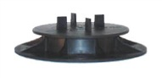 | B1 | Adjustable Pedestal 3/16” (4.5 mm) tab | 1-1/4” to 2” (32 to 51 mm)
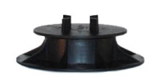 | B2 | Adjustable Pedestal 3/16” (4.5 mm) tab | 2” to 3” (51 to 76 mm)
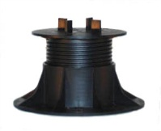 | B3 | Adjustable Pedestal 3/16” (4.5 mm) tab | 3” to 4-3/4” (76 to 121 mm)
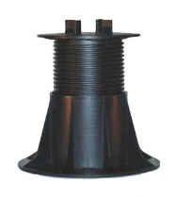 | B4 | Adjustable Pedestal 3/16” (4.5 mm) tab | 4-3/4” to 7-3/4” (121 to 197 mm)
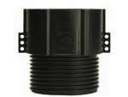 | C4 | Coupler  For use with Model B3 or B4 only | Adds up to 4” (102 mm) each
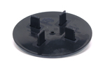 | VT316 | Ultra Low Height Pedestal 3/16” (4.5 mm) tab | 1/8” (3.2 mm)
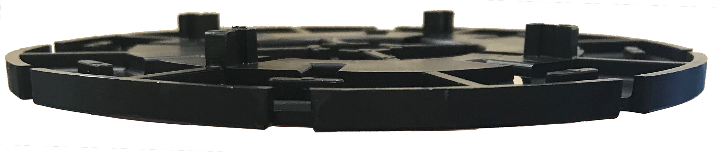 | HD25-316 | Fixed Height Stackable Pedestal 3/16” (4.5 mm) tab | 1/4” (6 mm)
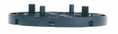 | HD50-316 | Fixed Height Stackable Pedestal 3/16” (4.5 mm) tab | 1/2” (13 mm)
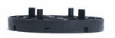 | HD75-316 | Fixed Height Stackable Pedestal 3/16” (4.5 mm) tab | 3/4” (19 mm)
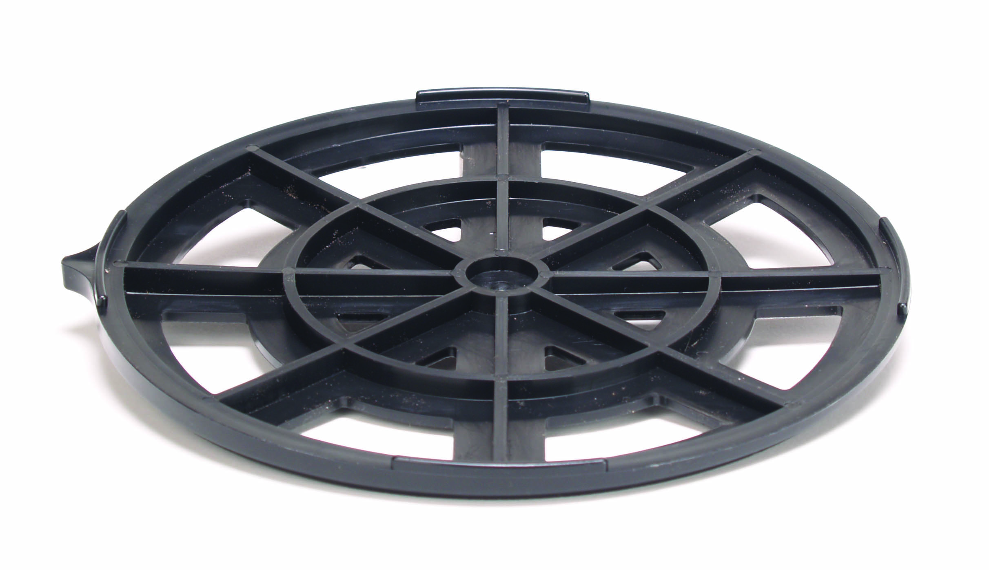 | LD4 | Base Leveler  For 1/4” per foot (2%) slope compensation | Adds 1/4” (6 mm)
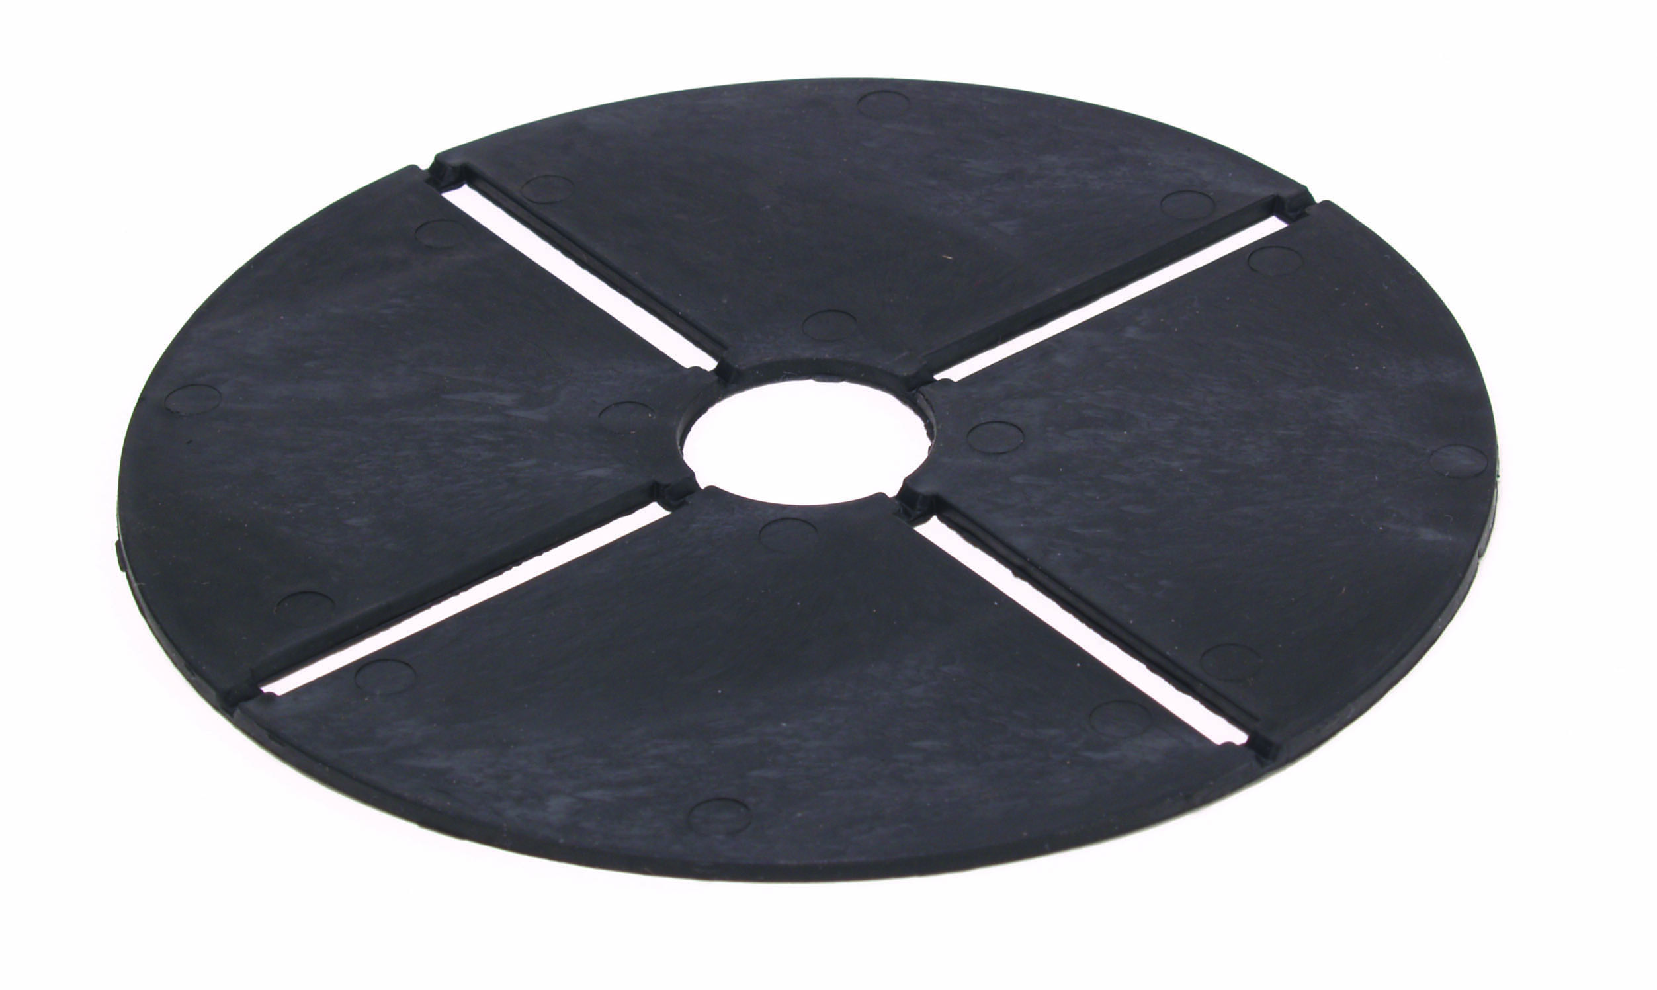 | B11 | Flexible Shim | 1/16” (1.5 mm)
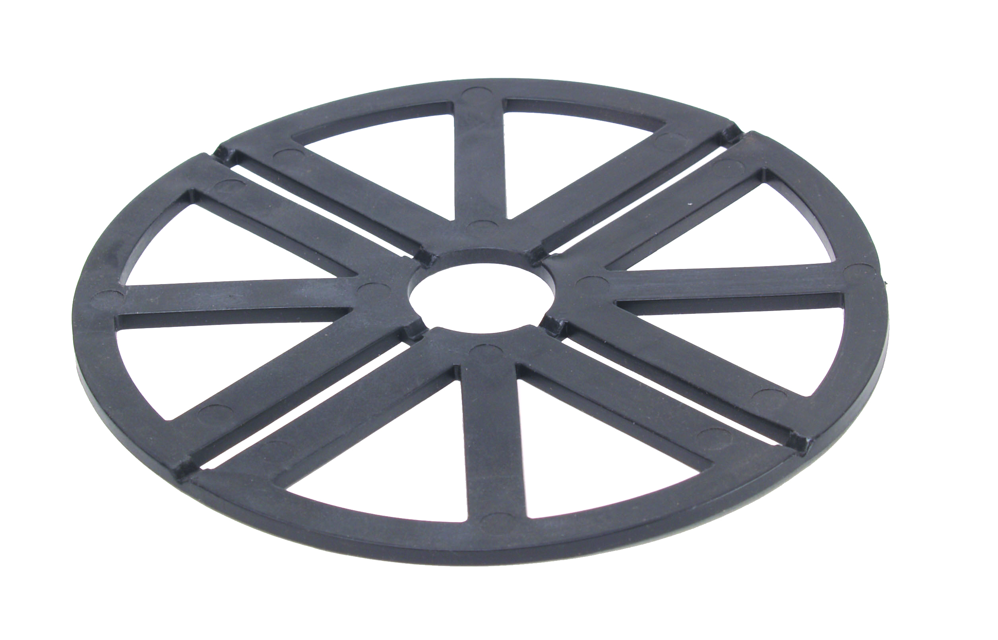 | PS1 | Rigid Shim | 1/8” (3.2 mm)
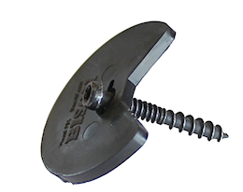 | FS-1 | Wood Tile Fastening Kit  Includes 2 screws | Fastens Bison Wood Tiles to Bison Adjustable Pedestals with long screw, and HD50 or HD75 Fixed Height Pedestals with short screw
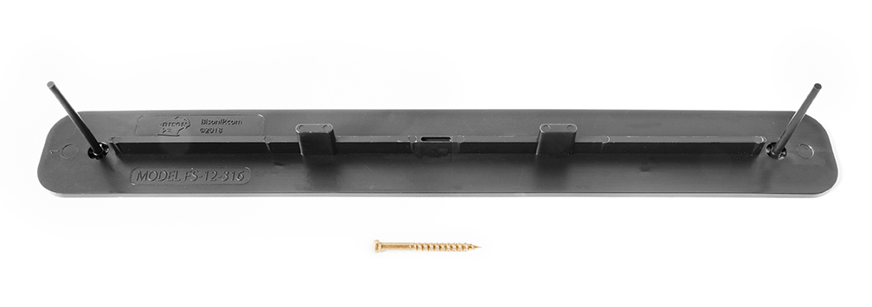 | FS-12 | 12” (305 mm) Fastening Spline  3/16” (4.5 mm) Tab  Includes 2 screws | Fastens Bison Paver Trays to Bison Adjustable Pedestals with long screw, and HD50 or HD75 Fixed Height Pedestals with short screw
 | FS-12-WT | 12” (305 mm) Fastening Spline  3/16” (4.5 mm) Tab  Includes 2 screws | Fastens Bison Wood Tiles to Bison Adjustable Pedestals with long screw, and HD50 or HD75 Fixed Height Pedestals with short screw
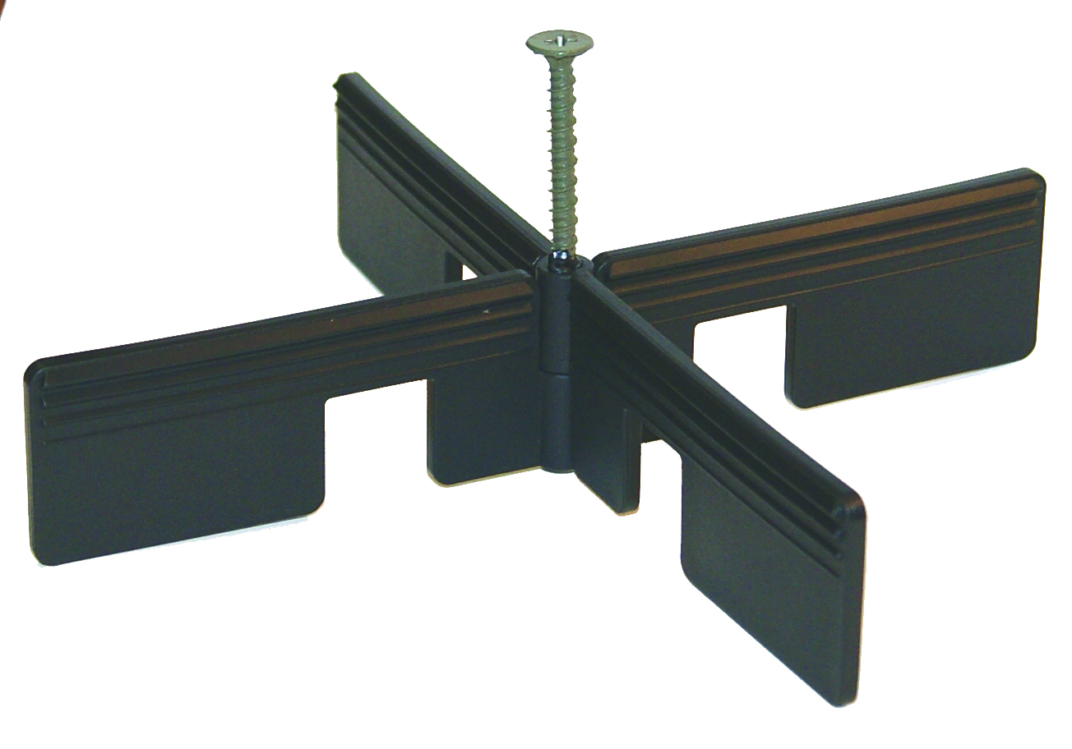 | BB-Wedge | Spacing Wedge  Includes 2 wedge pieces and 1 screw | --
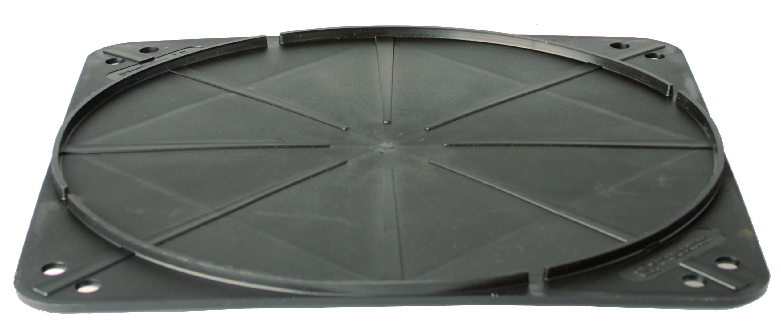 | FFB | Floating Foundation Base  For use over soil | 12” x 12” x 1/4”  (305 x 305 x 6 mm)
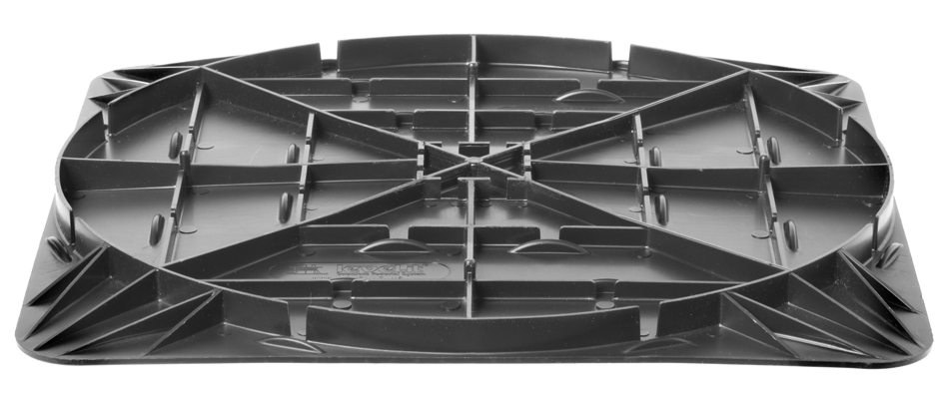 | FIB | Floating Insulation Base  For use over roofing systems with 20 to 40 psi insulation | 12” x 12” x 7/16”  (305 x 305 x 11 mm)
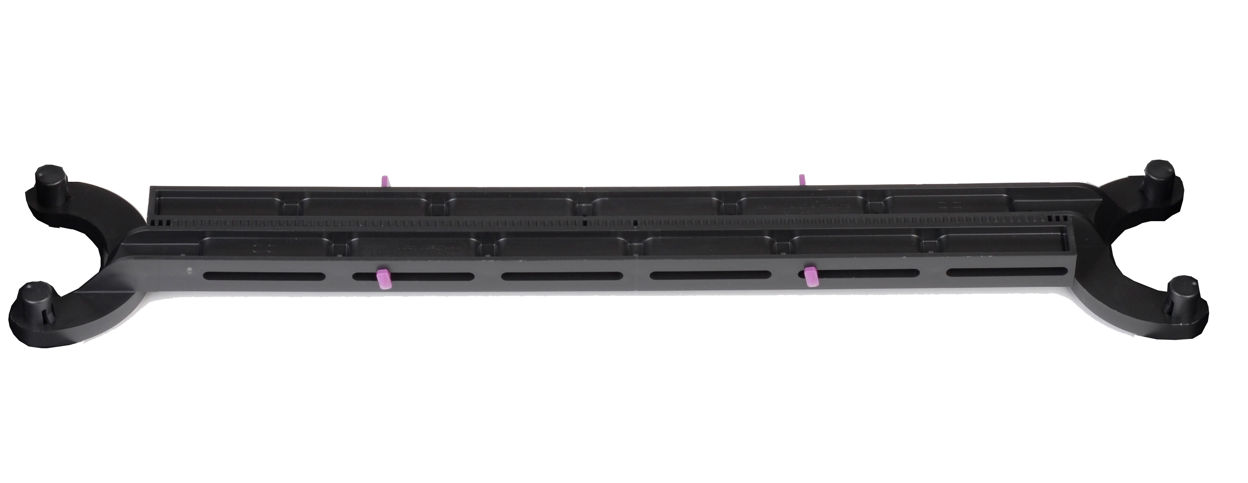 | BB-BRACE | Brace Kit  Includes 2 brace pieces and BB-Latch fasteners | Fits 11-3/4” to 36” Pavers  (299 to 914 mm)
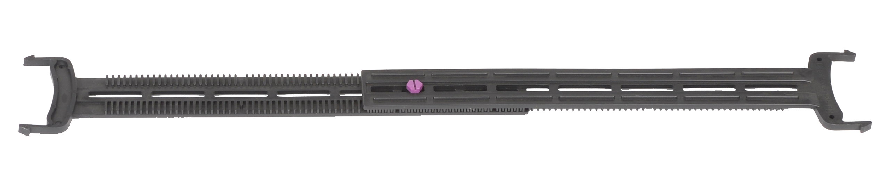 | BB-FH | Fixed Height Brace Kit  Includes 2 brace pieces and BB-Screw fasteners | Fits 8-1/2” to 25-1/2” Pavers  (216 to 647 mm)
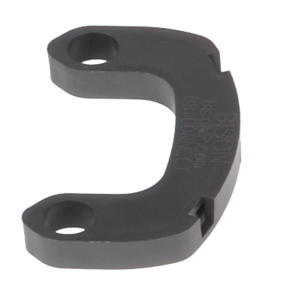 | BB-CONNECT | Fixed Height Brace Connector  Connects BB-FH to Adjustable Pedestals | --
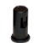 | BB-PEG | Pegs  Fits Models B1 to B4 | --

